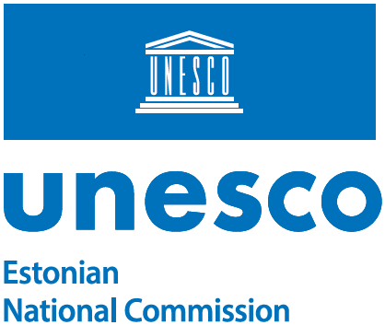

Acad. Dr. Vaira Vīķe-Freiberga
President of the Republic of Latvia (1999-2007)
L’Oréal-UNESCO for Women in Science Programme Baltic Honorary Patroness
Chancery of the President of Latvia
Pils Laukums 3, Riga LV-1900, Latvia
info@president.lv
Chancery of the President of Latvia, Pils laukums 3, Riga LV-1900, Latvia
info@president.lv | Ours: 18.12.2025 | No 14-7.2/1304-2

Your Excellency,

Thank you very much for your letter and recommendations regarding the L’Oréal-UNESCO for Women in Science Programme, which have been well received. We share your conviction that it is important to enhance the visibility of female scientists, promote gender equality in the scientific world, and inspire the next generations of researchers. This is why the Academies of Sciences and the National Commissions for UNESCO, in cooperation with the Ministries of Education of the three countries, have awarded “Baltic Women in Science“ fellowships since 2024.
We would also like to thank you personally for serving as an inspiration to young female scientists in the entire Baltic region.

Yours sincerely,

Kerli Gutman-Normak
Secretary-General

Additional recipients:
Latvian National Commission for UNESCO
Lithuanian National Commission for UNESCO
Estonian Academy of Sciences
Latvian Academy of Sciences
Lithuanian Academy of Sciences

